Animal-Care Veterinary Clinic II
Presented to | Houria Houmel
Part I System analysis
Presented by : Jimena Marin, Sofia Guerra, David Molano, Juan Pablo Monroy
2025
Table des matières
Database Analysis 0
Database Design (ERD & RDM) 0
ERD: 0
RDM: 0
T-SQL Database Implementation 0
Table Creation 0
Procedures 2
Views 3
Triggers 4

Database Analysis

Database Design (ERD & RDM)

ERD:

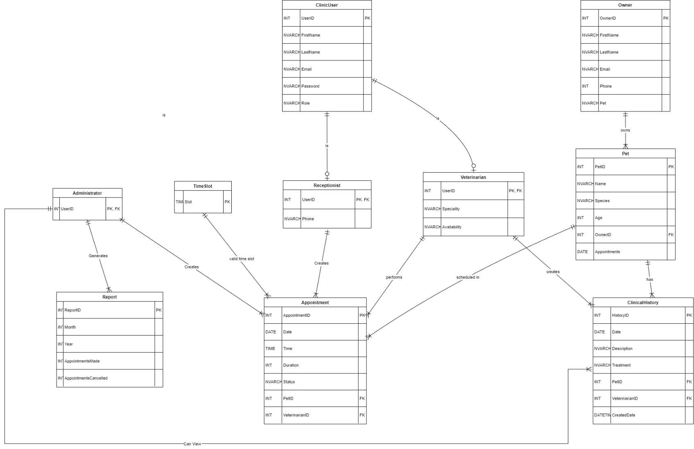

RDM:
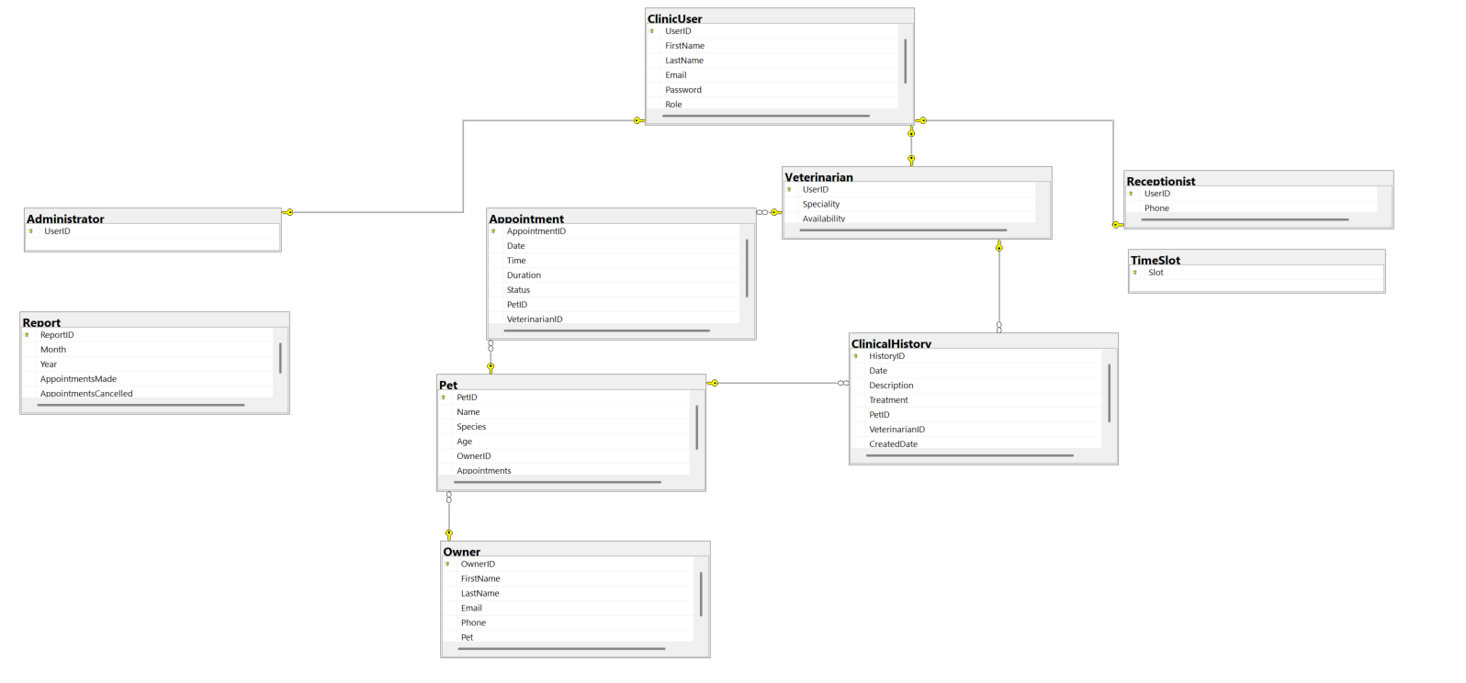

T-SQL Database Implementation

Table Creation

ClinicUser
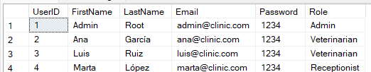

Administrator
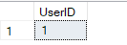

Veterinarian
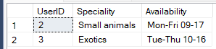

Receptionist
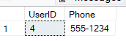

Owner
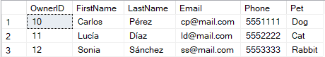

Pet
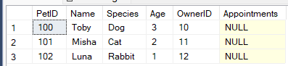

Appointment
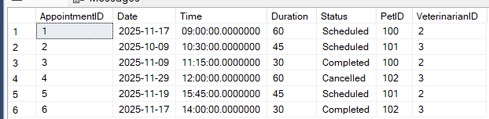

ClinicalHistory
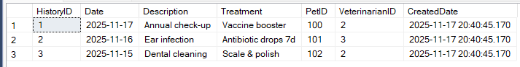

Report
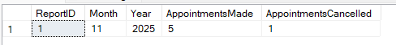

TimeSlot
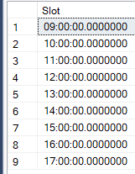

Procedures

sp_new_appointment
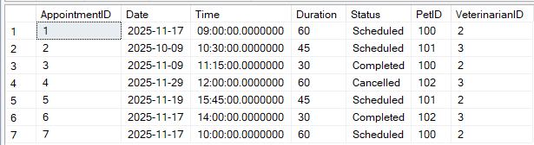

sp_cancel_appointment

sp_monthly_report
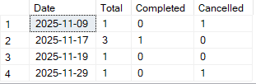

sp_upload_history
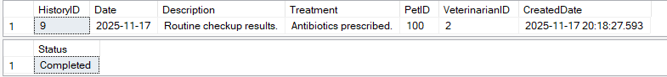

Views

Appointments agenda
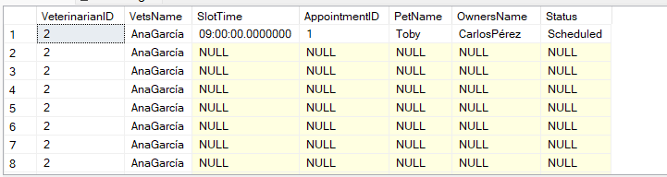

Monthly vet's workload
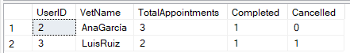

Clinic History
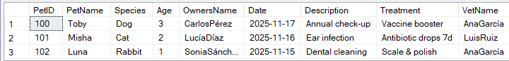

Slots Available
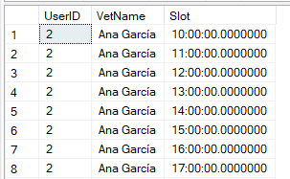

Triggers

delete_pets_from_owner
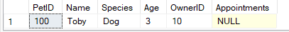

delete_pet_data
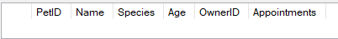

cancel_appointments_afterDelete
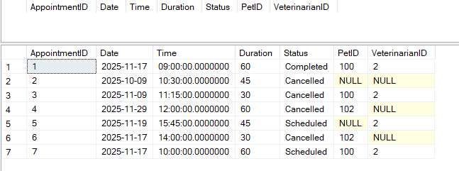

cancel_future_appointments

